M. Ali. Arslan

19F-0348

Lab Tasks

1. SELECT * FROM emp WHERE EMPNO = 7876 or EMPNO = 7934;

1. SELECT * FROM emp WHERE EMPNO = 7844 or EMPNO = 7782 or EMPNO = 7934;

SELECT * FROM EMP WHERE EMPNO IN(7844, 7782 ,7934);

1. SELECT Ename FROM emp WHERE DEPTNO=10 AND Job='Manager';

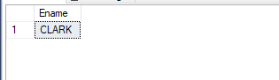

1. SELECT ENAME,JOB,SAL FROM emp WHERE HIREDATE= '1981-01-01';

1. SELECT ENAME,JOB FROM emp WHERE DEPTNO= 30;

1. SELECT ENAME,JOB FROM emp WHERE SAL>=1000 AND SAL<=2000;

1. SELECT ENAME FROM EMP WHERE JOB='MANAGER' AND SAL>2500;

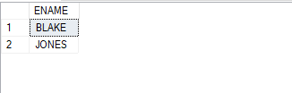

1. SELECT * FROM EMP WHERE JOB!='SALESMAN' ;

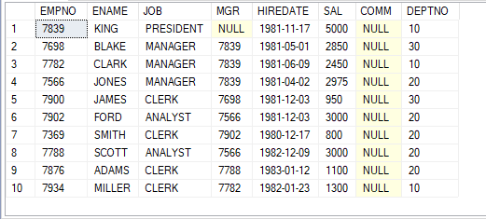

1. SELECT * FROM EMP WHERE MGR!=0 ;

1. SELECT SAL + (SAL * 6/100) as TOTAL_SAL, ename FROM EMP;

1. SELECT * FROM EMP WHERE SAL<1000 OR SAL>1300 AND DEPTNO=30;

1. SELECT ENAME, JOB, DEPTNO FROM EMP WHERE ENAME LIKE 'J%' AND ENAME LIKE '%ES';

1. SELECT ENAME, JOB, DEPTNO FROM EMP WHERE ENAME LIKE '%AM%';

1. SELECT * FROM EMP WHERE ENAME LIKE 'A%' OR ENAME LIKE '%N';

1. SELECT ENAME FROM EMP WHERE ENAME LIKE '_L%' AND LEN(ENAME)=5;

